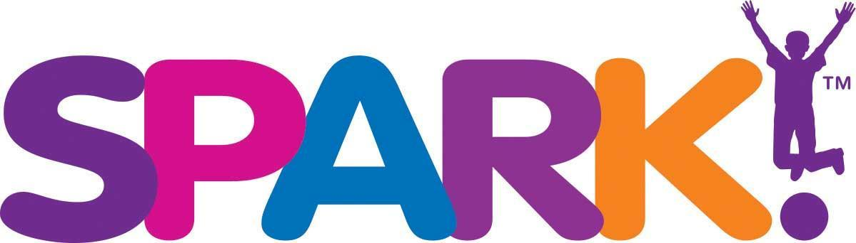

Job Descriptions: Guest Creativity Guide
(Part Time - primarily on weekends and some evenings)
Reports to: Manager on Duty and ultimately to the Chief Operations Officer

Position Summary: These individuals are energetic, outgoing and dedicated to showing our guests a great time as the guests engage in exploration, play, discovery and creative experiences. You must have a warm smile, great attitude and enjoy meeting a wide variety of people.

Essential Functions and Responsibilities:
- Provide a high level of customer service
- Present yourself in a professional manner
- Effectively communicate with guests
- Learn SPARK! history, mission and vision and be able to share with guests
- Set-up, take down, light cleaning and trash removal
- Available to work on weekends, minor holidays and special events
- Other duties as assigned

Qualifications:
- An understanding of the creative process
- Ability to communicate in a clear, precise and friendly manner
- Excellent customer service skills
- Maintain neat, professional appearance
- High energy level and can-do attitude
- Previous experience working with children and their parents preferred
- Must be a self-starter
- Must be at least 16 years old with reliable transportation
- Must be able to work in the U.S

Essential Physical Requirement:
- Must be able to capably lift 25 pounds, bend comfortably at the knees and waist, and twist.
- While performing the duties of this job, the employee is frequently required to stand, walk, stoop, kneel, crouch or crawl and occasionally required to sit and climb or balance.
- The physical demands described here are representative of those that must be met by an employee to successfully perform the essential functions of this job.

Hours: Hourly, primarily Saturdays 9:00 - 5:00 and Sundays 11:00 - 6:00. There will be some seasonal variations, along with periodic evening or weekend events.

Please send cover letter & resume to: careers@sparkdallas.org

