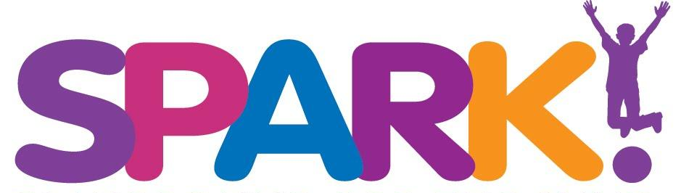

Job Description: Programming Assistant
Reports to: Chief Operations Officer
Position Summary: This individual is the glue that keeps the programming team operating smoothly. As we have a small, but collaborative staff. Our Programming Assistant will be called upon to support a variety of programs, events and other such needs.
Job Responsibilities:
- Complete registration for all programs: field trips, camps, after school programs and sometimes adult events
- Track visitors and assist as needed in reaching out and engaging them through sign-up mechanisms
- Support instructors and operations team with program and event preparation and execution
- Assist in capturing and recording success stories and providing content for newsletters
- Schedule and verify payment for field trips
- Greet walk-in visitors
- Support instructors and operations
- Answer phones
- Other duties as assigned

Required Skills:
- 2+ years previous administrative or scheduling experience required
- Excellent PowerPoint, Excel, Word, and Google drive knowledge
- CRM proficiency required, Salesforce is a plus
- Excellent time management skills
- Organized and able to work in a fast-paced environment
- Unquestionable integrity
- Self-starter, self-managing
- Passion for creativity
- Personable, loves working with the public
- Strong verbal and written communication skills
- Non-profit experience, a plus

Must possess a valid driver's license. Must be eligible to work in the U.S.

Hours: Full Time, primarily Monday through Friday during business hours. There will be some seasonal variations, along with periodic evening or weekend events.

This job description is not all-inclusive and subject to change without prior written and verbal notification.
Please send cover letter & resume to: careers@sparkdallas.org

