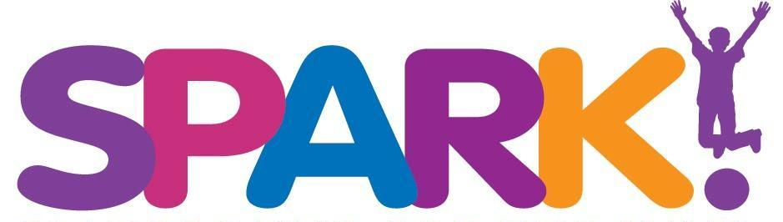
Job Description: Manager On Duty (Part Time- primarily on weekends and some evenings available)
Reports to: Chief Operations Officer

Position Summary: Works directly with the public during open hours and special events. Oversees operations staff, facility and visitor experience for SPARK! The MOD is responsible for the facility and our guests. The MOD must have strong communication and relational skills and be a collaborative creative problem solver

Job Responsibilities:
- Help foster a positive work environment
- Maintain accurate accounting from Point of Sale transactions
- Support fundraising/donation efforts
- Demonstrate good judgment in handling customer needs
- Ability to solve and navigate conflict. Consensus building
- Ability to train hourly staff on their job requirements
- Have a strong knowledge of SPARK! history, mission and programs to share with guests
- Oversee special events and birthday parties to ensure excellent experiences
- Light administrative duties such as reporting, and timekeeping approvals
- Direct, oversee, and manage operations, assign tasks, and supervise staff during shifts
- Uphold and enforce company policies and procedures
- Maintain an efficient, organized facility that encourages productivity at all times
- Build and maintain positive client and customer relationships
- Other duties as assigned

Qualifications:
- Must be able to lift 25 pounds
- Must possess strong interpersonal communication skills
- Teamwork oriented
- Creative thinker
- Adaptable in responding to change
- Self-motivated
- Spanish is a plus
- Any physical demands described here are representative of those that must be met by an employee to successfully perform the essential functions of this job.
- While performing the duties of this job, the employee is frequently required to stand, walk, stoop, kneel, crouch or crawl and occasionally required to sit and climb or balance.
- Must possess a valid driver's license.
- Must be eligible to work in the U.S.

Hours: Hourly, primarily Saturdays 9:00 - 5:00 and Sundays 11:00 - 6:00. There will be some seasonal variations, along with periodic evening or weekend events.

Please send cover letter & resume to: careers@sparkdallas.org

